**Project title:**

Uncovering the gaming industry’s hidden gems: A comprehensive analysis of video game sales

**1 Introduction:**

**1.2Overview**

In this the main goal was to analyze the sales of video games in different regions. The regions are North America, Europe, Japan, other countries (comined) and then the global sales (total of all the regions). The main idea was to visualize the sales for different genres, publishers and platforms. This would give the basic idea about the most popular genres, publishers and platforms amongst all. Also analyzing the effect of genres on sales in different regions.

**1.2 Purpose**

Video games offer a safe place to improve your skill and get better at something. Some video games have a high skill cap – high level of difficulty to become masterful. However, those same games also help beginners get involved by giving them positive reinforcement for the little good things they do.

**2 Problem Definition & Design Thinking:**

**2.1 Empathy Map**

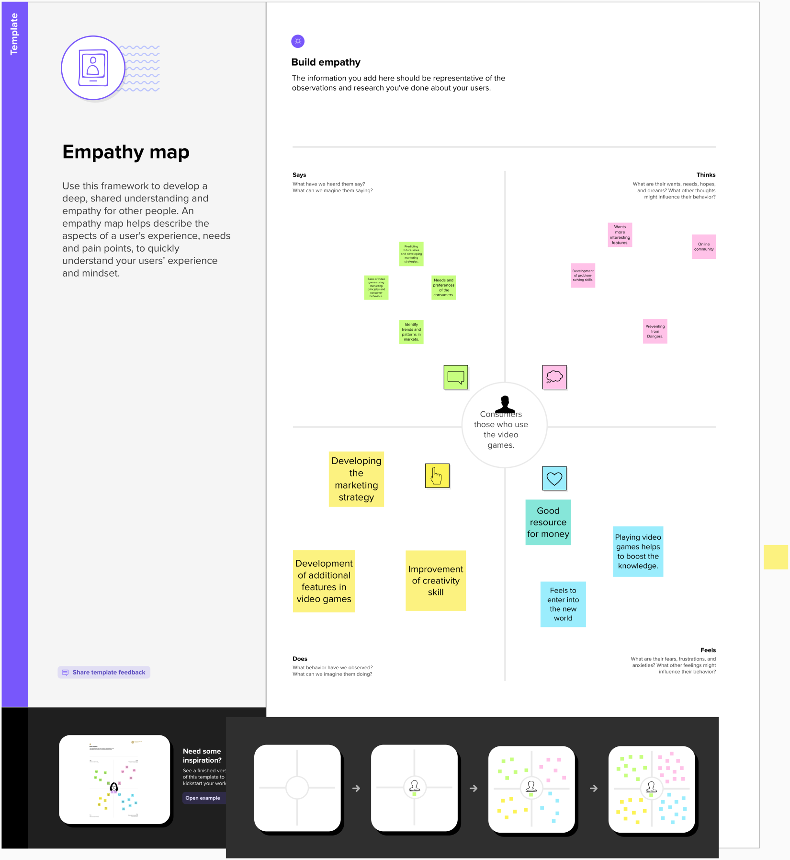

**2.2 Ideation & Brainstorming Map**

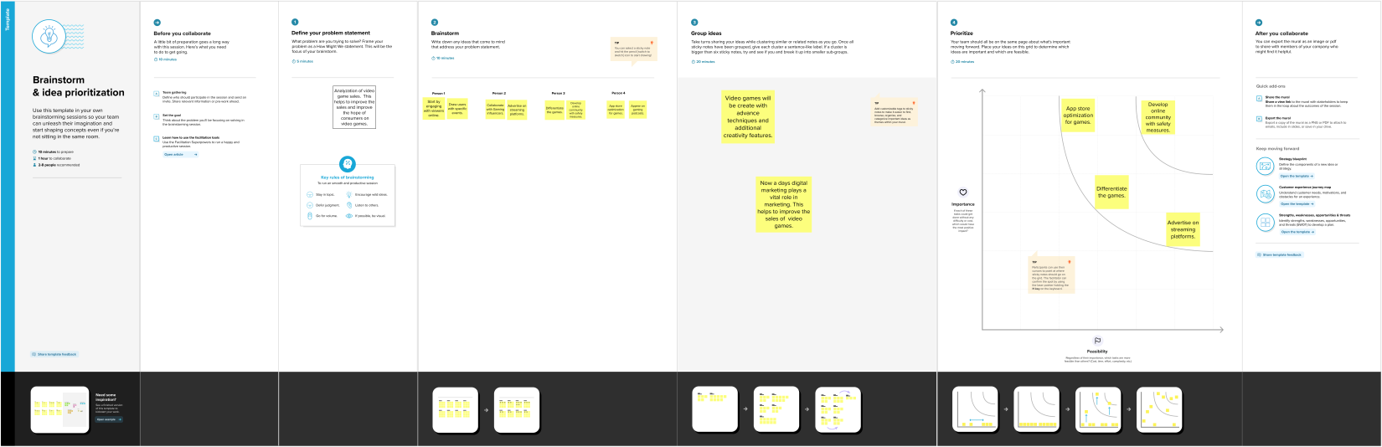

**3 RESULT :**

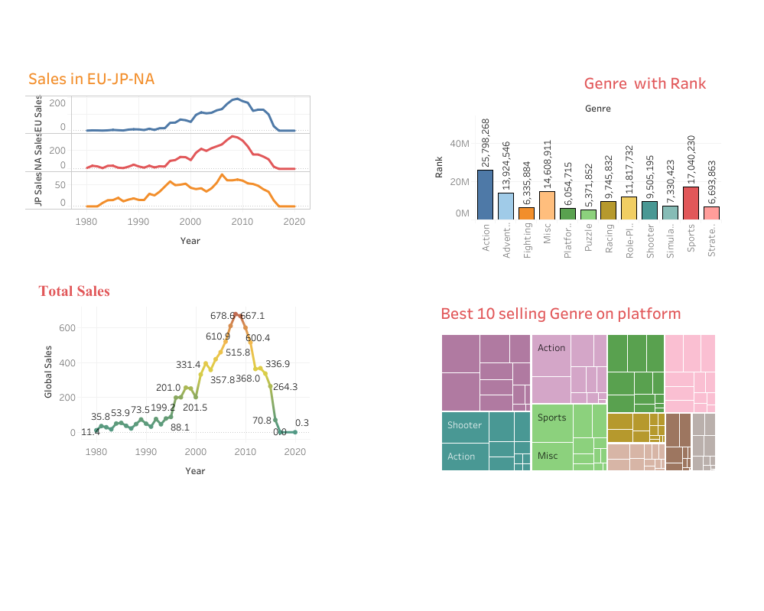

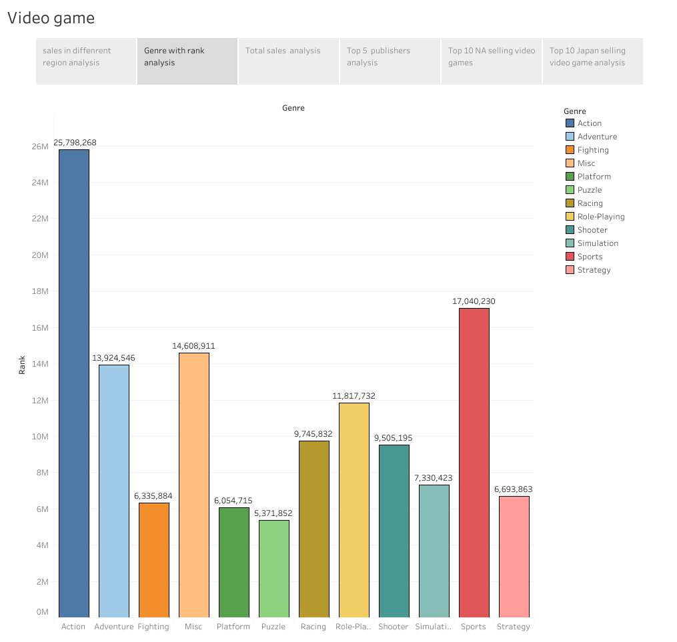

**4 ADVANTAGES**

* + **Games are fun and source of positive emotions.**
  + Playing games bring people together, it is the competition among peers that adds adrenaline.
  + Playing games is like yoga for your mind (may be perfect for the inflexible part of population).
  + Games help us tap into positive emotions, like curiosity, optimism, creativity. You enjoy it just for the sake of enjoying.
  + Some people need a lot of effort to coordinate eye and hand movement, you can observe this especially in fast-paced games.

**DISADVANTAGES**

* Spending too much time playing video games can lead to a **lack of social interaction** and isolation from friends and family.
* Playing video games increases the **risk of obesity** because they encourage more eating and less physical activity.
* Students who spend a lot of time playing video games may **perform poorly in school** due to a lack of focus and study time.
* Some video games may contain **content that is not suitable for children** or may expose them to inappropriate themes or language.
* **Video games can be expensive**, and the cost of purchasing new games and console systems can add up over time.

**5 Applications**

* Gaming Applications means all applications, supporting documents and supplemental information required by any Gaming Authority or required pursuant to any applicable Gaming Law necessary to effectuate the provisions set forth in any of the Transaction Documents

**6 CONCLUSION**

Video games are a form of media that is often associated with negative health consequences. However, when games are played in moderation and with mindfulness, they are a viable source of stress relief as well as a catalyst for mental health improvement and development of social skills

By the above data we can say that action games on DC or playstation for that matter are the most popular and are the ones responsible for maximum sales all over the globe. Also as these games are so abundant and popular (ranking wise), variation in the sales of one or two such games would not cause significant change in the overall sales.

**7 FUTURE SCOPES**

From the above visualizations we can clearly say that DC and Play Station are the most popular platforms amongst all followed by Xbox. Action genre is the most popular genre of all and is followed by sports and fighting respectively. We can also see that Daito is the most popular followed by TYO and Mirada respectively.

From the above tests we can say that the genres less popular cause significant change in sales in all regions as compared to the ones that are more popular.

`